PAANI PROGRAM | पानी परियोजना

[INSERT CREDIT] For USAID

Sediment transport in the rivers of Nepal (Interim Report)

Modeling and analyzing sediment transport and origins with a special focus on the Karnali basin

Cover photo: [insert caption]

Photo credit: [Insert photographer’s full name] for USAID Paani Program

PAANI PROGRAM | पानी परियोजना  
Sediment transport in the rivers of Nepal (Interim Report)

Modeling and analyzing sediment transport and origins with a special focus on the Karnali basin

#### Program Title: USAID Paani Program

#### DAI Project Number: 1002810

#### Sponsoring USAID Office: USAID/Nepal

#### IDIQ Number: AID-OAA-I-14-00014

#### Task Order Number: AID-367-TO-16-00001

#### Contractor: DAI Global LLC

#### Date of Publication: April 9, 2020

#### author: Rafael SchMItt

Contents

introduction 1

Geomorphology of rivers in Nepal 2

Sediment transport in Nepal, an annotated bibliography 6

Methods and data 7

Measured suspended sediment data 7

Analyzing sediment data 8

Converting and interpreting sediment yields and loads 8

Converting and interpreting denudation rates 9

Modelled Suspended sediment data 9

Estimating rates of bedload transport 10

Geomorphic clustering 12

Results 13

Magnitude and uncertainty of suspended sediment transport 13

Estimating bedload transport rates 1

Comparing DHM and radio-nuclide data for the Karnali basin 1

Applicability of global erosion models to Nepal 2

Modeling suspended and bedload transport in Nepal 4

Geomorphic clustering 6

Conclusion 9

References 10

# introduction

High relief, monsoonal rain and rapid uplift drive erosion processes in the Himalayas make the rivers of the region outstanding in terms of sediment transport. For example, the Ganges-Brahmaputra system conveys an estimated sediment load 1.4 billion tons of sediment to its lower floodplains and the delta, of which 1.0 billion tons, equaling 8 – 10 % of the global sediment delivery to the oceans, reach the Gulf of Bengal. Around 600 - 800 million tons of sediment originate from tributaries of the Ganges that drain the southern-facing slope of the Himalayas and most of that sediment is contributed by rivers that originate in Nepal (Lupker et al., 2012; Wasson, 2003; Goodbred and Kuehl, 1999). However, while Nepal’s rivers are certainly outstanding with regard to the amount of sediment that they transport the linkages between sediments, river processes, ecosystems and infrastructure in these rivers are sparsely monitored and understood incompletely.

This report aims to explore available data as a basis for better modeling spatial patterns of sediment origins and sediment transport in the rivers of Nepal and how they might be impacted by infrastructure development. A key challenge for evaluating sediment transport rates in the rivers of Nepal is data availability. Most scientific papers and reports are based on evaluating all or sub-sets of the ~20 hydrologic gauging stations where sediment has been measured over the past decades by Nepal’s Department of Hydrometeorology (DHM). Often, different stations on the same river only operated in not-overlapping periods of time, making it hard to effectively constrain river sediment budget. Sometimes, these data by DHM are supplemented with observations that were derived for designing specific engineering projects, e.g., hydropower dams or irrigation projects, even though the poor documentation for many of these data makes them mostly of anecdotal use.

However, compared to other geogrpahies, there is a significant wealth of studies aiming to understand the geomorphology of the Himalaya and its rivers using geochemical approaches. While targeted to understand processes on much longer timescales, the data underlying these studies provide an independent validation and consistency check for the sparse sediment data available from DHM. Thus, the results of these studies could possibly be leveraged for better river management.

An additional challenge is that nearly all published studies for which data are available focus on rather downstream parts of major rivers. Thus, the availability of data is not well aligned with the hotspots of infrastructure development, with many possible projects in upper parts of the rivers. As a consequence, planning will need to rely on numerical models to estimate sediment transport processes in unmonitored parts of the country.

Based on these premises, this report aims to:

* provide an overview over available sediment data
* constrain uncertainty in available sediment data
* evaluate applicability of global erosion models for representing sediment transport
* estimate unmonitored bedload transport model for the rivers of Nepal

We first lay out the most important available data sources for sediment transport in Nepal in an annotated bibliography. We then describe methods used to convert data from different sources for comparison and cross validation. For the example of the Karnali river, we describe in detail how data from different sources and time periods can be used to constrain the contemporary sediment budget of a river. Finally, we use sediment observations to validate if a global erosion model (Borrelli et al., 2017) could be a practical way forward to model sediment transport in all rivers of Nepal. Finally, we propose an empirical model for bedload transport in Nepal which, despite its certainly great magnitude and its importance for rivers and infrastructure, remains largely unmonitored throughout the country.

## Geomorphology of rivers in Nepal

Three of the four major tributaries of the Ganges originate or flow through Nepal, the Karnali, the Narayani, and the Koshi river system. All three rivers originate either from the Tibetan Plateau (Koshi River). After traversing the main mountain chains of the high Himalayas in deep gorges, they flow southward through the lesser Himalayan mountains until they cut through the Siwalik range, where they enter the Gangetic plains. Notably, the similarity in their general course exposes rivers in certain characteristic gradients and environmental conditions that drive their hydrology and possibly their sediment transport.

For example, Kondolf and Minear proposed an expert based zonation of river basins according to geologic and climatic drivers into so called geomorphic provinces (Kondolf et al., 2014; Minear and Kondolf, 2009). The idea behind this approach is that rivers in a geomorphic province will receive similar sediment inputs, because the processes that generate sediment are similar. For the river of Nepal, there are several hydroclimatic and geologic variables that vary considerably across the river basins of Nepal. First, orographic effects and monsoonal storms create precipitation of up to 5000 mm per year in the lesser Himalaya region. High precipitation coincides with area of extreme topographic relief and deeply incised rivers, creating conditions where massif mass movements are supplying large amounts of sediment (Struck et al., 2015). This is in stark contrast with the high mountain valleys north of the Himalaya main chain, where precipitation is an order of lower magnitude. Because of the extremely cold and arid climate, these areas are very sparsely vegetated and possibly prone to erosion. However, evidence from Mustang valley in the upper Narayani suggests that erosion and sediment supply to rivers is likely low because of the low precipitation (Vogl et al., 2019; Struck et al., 2015). Large glaciers exist along the main chain of the Himalayas, which create a source of sediment that is very poorly constrained (Vogl et al., 2019). Available studies for the lesser Himalayas and the Siwalik indicate that erosion and thus sediment supply is driven by local uplift and proximity to major fault lines (Godard et al., 2014; Attal and Lavé, 2009).

We collected spatially distributed information on most relevant drivers to develop a spatially explicit hydromorphologic characterization of river basins in Nepal. Therefore, we first divided the entire area of interest, i.e., the drainage area of all rivers that originate or pass through Nepali territory into small catchments. Each of the small subcatchments was then assigned the mean of five geomorphic covariates that are possibly related to sediment yields and river processes. For this demonstration, we used (1) relief (defined as elevation difference within a 5000 m window[1]) and elevation calculated from the DEM, (2) precipitation, (3) k-factor as used in USLE[2], (4) distance to major fault lines (Figure 2). Comparing maps for different drivers show a clear north to south gradient, with most covariate values showing highest values in the center of the country, giving a strong indication about hotspots of erosion and sediment supply to rivers that is mostly in accordance with evidence available from peer-reviewed papers and reports (see Annotated Bibliography) and we use this information subsequently to delineate geomorphic provinces using a novel, machine learning approach.

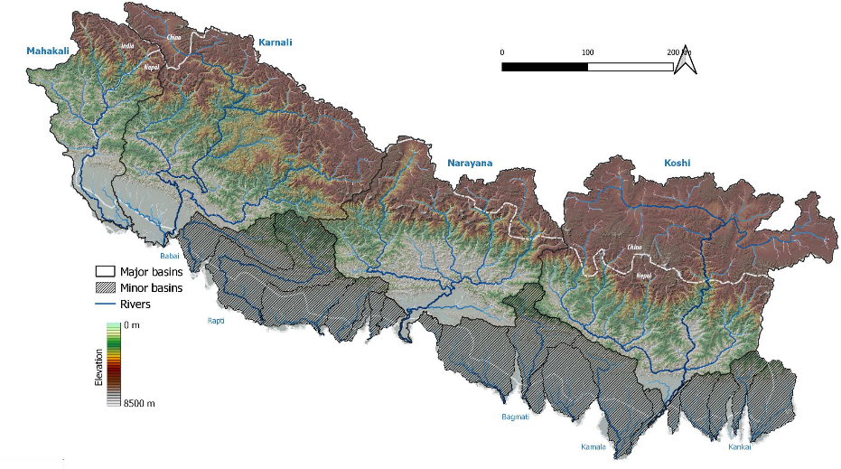

Figure : Geography of the major rivers of Nepal. Clear areas show the drainage basins of the four major rivers of Nepal. Hatched areas indicate smaller river basins in the south of the country

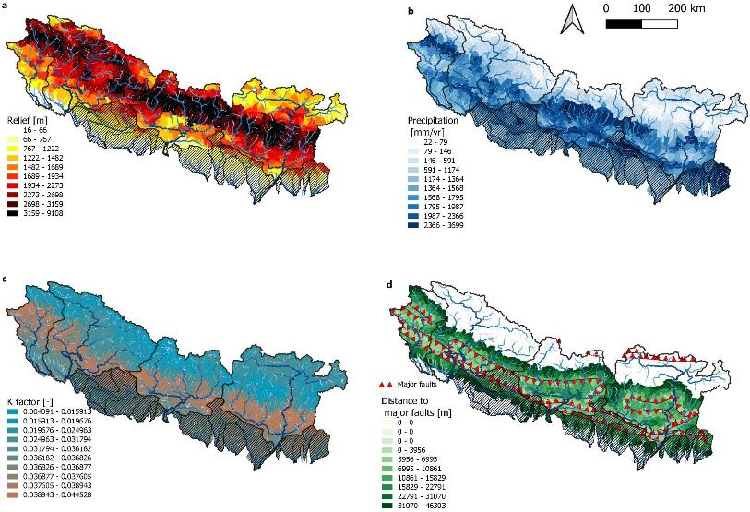

Figure : Geomorphic drivers of sediment transport and geomorphology. Maps show the spatial distribution of relief (defined as elevation difference within a 5000 m window) (a), precipitation (b), erodibility (c) and distance to major fault lines (d). In combination, these factors are possible determinants for spatial variation in sediment yields and river processes in Nepal. Conceptually, higher rainfall intensity, high relief , high erodibility , and close proximity to faults will cause more local erosion than low values for these factors.

## Sediment transport in Nepal, an annotated bibliography

This section gives some more details on the key sources of information that were used to compile sediment data for this report. They were mostly selected based on their usefulness, the amount of data they present, and how widely they are cited in pertinent literature on Nepal. However, there is a wealth of additional references that can be found in the full bibliography.

* **Andermann, C., Crave, A., Gloaguen, R., Davy, P. & Bonnet, S. Connecting source and transport: Suspended sediments in the Nepal Himalayas. Earth and Planetary Science Letters 351–352, 158–170 (2012).** Andermann et al. analyze records at 11 DHM gauging stations and 1 station operated by a hydropower company. Based on these data, Anderman et al., provide annual mean transport rates and uncertainty ranges for all major rivers in Nepal. To our knowledge, the data provided in Anderman are the most complete collection of sediment data.
* **Attal, M. & Lavé, J. Changes of bedload characteristics along the Marsyandi River (central Nepal): Implications for understanding hillslope sediment supply, sediment load evolution along fluvial networks, and denudation in active orogenic belts. in Tectonics, Climate, and Landscape Evolution (Geological Society of America, 2006). doi:10.1130/2006.2398(09).** Attal and Lavé focus on sediment transport processes in the Marsyandi River in central Nepal. While the focus of their work is to understand longer term coupling of geomorphic processes on hillslopes and river, they also provide some of the only estimates of bedload transport dynamics available for Nepal.
* **Sinha, R. et al. Basin-scale hydrology and sediment dynamics of the Kosi river in the Himalayan foreland. Journal of Hydrology 570, 156–166 (2019).** Sinha et al. Analyse sediment data from the Kosi river system. Despite being one of the major rivers in Nepal, the Kosi river system is very poorly monitored. Unfortunately, most analysis presented in the paper are based on very short time series of sediment transport and data are not reported in a format that would allow their use in a quantitative analysis.
* **Yogacharya, K. S. A Review on Status of Sediment Studies in Nepal. Journal of Hydrology and Meteorology 5, (2008).** Yogacharya provides a review of sediment data that were collected for specific engineering projects. While there is no way to independently estimate the quality of these data and how they were derived, Yogacharya’s review provides an important set of data that are different from DHM’s data set.
* **Lavé J. & Avouac J. P. Fluvial incision and tectonic uplift across the Himalayas of central Nepal. Journal of Geophysical Research: Solid Earth 106, 26561–26591 (2001).** Lavé and Avouac’s paper is prototypical for papers that aim at understanding the coupling between earth surface and river processes based on observations from the Himalayas. While not the objective of the paper, their data can be very useful for management applications. Specifically, they provide a transversal section across the major rivers of central Nepal, and the longterm cosmogenic estimates of denudation can provide an independent check on dissolved sediment samples.
* **Ojha, L., Ferrier, K. L. & Ojha, T. Millennial-scale denudation rates in the Himalaya of Far Western Nepal. Earth Surface Dynamics Discussions 1–21 (2019) doi:https://doi.org/10.5194/esurf-2019-7.** Ojha et al. is one of the few studies that reports on original sediment data specifically for the Karnalli basin. Data are derived from cosmogenic nuclides, and thus representing an average over a longer timescales. However, they are an important independent data source.
* **Vogl, A. L., Schmitt, R. J. P. et al. Valuing Green Infrastructure: Volume I: Case Study of Kali Gandaki Watershed, Nepal. (2019).** Vogl et al. study the role of green infrastructure and land management to minimize geomorphic hazards and erosion in the Kaligandaki catchment. Sediment data for this report were collected by researchers from Kathmandu University over the 2018/2019 water year. These data are the only original raw data to which the authors of this report had access and provide the only insight in sediment origins on smaller scales, i.e., not for major basins, but on the scale of smaller sub-basins.

# Methods and data

## Measured suspended sediment data

This report is mostly built on transport rates reported in Anderman et al., (2012) based upon data collected from DHM at twelve stations. Of those twelve stations, only two are located in the Karnali basin. These data are complemented with data for the 5 stations in the upper Kaligandaki river (Vogl et al., 2019). Additional information is available from a number of reports and papers (see annotated bibliography). In general, data from Anderman et al., (2012) are considered as primary data source because of their consistency, while other data are used as an independent check on findings derived from Anderman et al.’s (2012) data (Figure 3).

Commonly, loads are calculated from sediment concentration measurements at the location of a discharge gauge. Sediment concentrations are multiplied with local discharge rates at the time of sampling to derive a load [Mass/Time] from concentration [Mass/Volume] X discharge [Volume/Time]. Often, a regression is fit between concentrations and discharge. From that regression, sediment concentrations and then load can be estimated from discharge alone. While this approach is subject to uncertainty because the correlation between discharge and sediment may change, it allows to estimate sediment transport for prior period for which there are only discharge measurements. Another major limitation is that sediment measurements reported by DHM are from different periods of time. I.e., some stations might have sediment measurements from the early 2000s, but at other stations sediment data have been derived only for few years in the 1980s and 1990s.

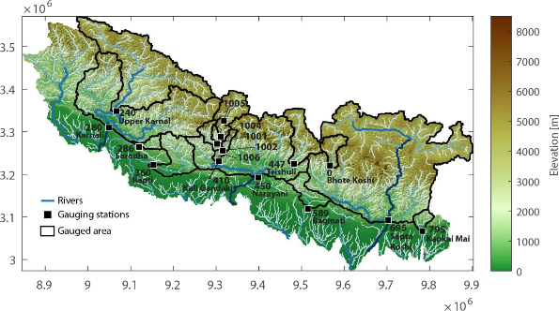

Figure : Geography of Nepal, key rivers, and gauged basins. Location of available sediment data based on the gauging stations reported by Vogl, Schmitt et al. (2019) (Id numbers > 1000) and Anderman et al. (2012). Thick black lines represent the area contributing each gauging station.

## Analyzing sediment data

### Converting and interpreting sediment yields and loads

Sediment yields refer to the amount of sediment that is mobilized from the hillslopes and reaches a downstream point in the river network. Sediment yield is calculated as sediment load [Mass/Time] normalized by the area draining towards a point of interest [Area]. Thus, loads can be converted to yields by

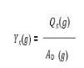

Where 𝑌s is the sediment yield [t/km2/yr], 𝑄𝑆 is the observed load [t/yr], 𝐴𝐷 is the drainage area [km2] and 𝑔 denotes a specific gauge with sediment observations. Sediment yields are useful to estimate sediment transport in unmonitored parts of a river basin. Assume that a river section of interest, 𝑟, that is upstream of gauge 𝑔, but without sediment data. In that case, sediment load for that reach could be estimated from the sediment yield at the downstream gauge and the drainage area of the reach of interest

𝐿𝑆(𝑟) = 𝑌𝑆(𝑔) ∗ 𝐴𝐷(𝑟)

While this approach is very common to quickly generalize point samples of sediment to larger areas, it is also subject to major uncertainties. This is because the sediment yield at a downstream point in the network is the result of spatially heterogeneous sediment delivery processes in the contributing area. Introducing a single, homogeneous value of sediment yield for the entire contributing area is thus not necessarily a good representation of sediment yields all throughout the contributing area.

### Converting and interpreting denudation rates

Denudation describes rates of the earth surface being worn away by water, ice, wind, i.e., erosion processes. In contrast to sediment yield, denudation is typically expressed in a length unit, e.g., [mm/yr]. This is practical for a number of reasons. First, many landscapes area in a quasi-equilibirum between uplift, i.e., the surface being lifted by tectonic forces, and erosion. As uplift is typically expressed in a length units [mm/yr], expressing denudation in [mm/yr], too, allows for direct comparison between both processes. A typical way of measuring denudation rates is using cosmogenic nuclides. Basically, these approaches determine which depth of new rock material is exposed at the land surface each year, thus resulting in an estimate of length per year. Sediment loads can be inferred from denudation rates via the following equation (units included for clarity):

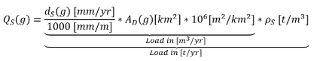

Where 𝑑𝑆(𝑔) is the reported denudation rate. Note that 𝑔 in this equation denotes the location of the measurement, which is not necessarily identical to the location of a gauging station. 𝜌𝑆 is the density of eroded rock material and is set to 2.65 in accordance with other studies (Andermann et al., 2012; Ojha et al., 2019)

It should be Loads calculated from cosmogenic nuclides have a set of distinctions from direct measurements of sediment transport. Those distinctions impose limitations but also open opportunities, notably:

* Cosmogenic nuclides at location in a river network allow to determine average denudation rates throughout the entire upstream area, independent of how the sediment is transported. Thus, denudation rates are a proxy for total sediment transport (bedload and suspended load), while sediment measurements typically cover only suspended load.
* Cosmogenic nuclides measure only gradual exposure of new material. Thus, processes that mobilize material from deeper layers of a hillslope are not well represented. This is a notable limitation in Nepal, where landslides are an important source of sediment.

### Modelled Suspended sediment data

Modelled sediment data are derived from a global model of hillslope erosion (Borrelli et al., 2017) based on the USLE model, that is exhaustively described elsewhere (Borrelli et al., 2017; Merritt et al., 2003). Those data can be accumulated into estimates of sediment yield for each river reach. Then, a routing algorithm is used to accumulate yields throughout the river network, eventually resulting in sediment loads in each river reach (Grill et al., 2019). At reaches where there are sediment measurements, modelled transport rates can be compared to observations for validation. It should be noted that estimates of erosion derived from the USLE model consider only for sheet and rill erosion of fine material (i.e., silt, sand), but not for other processes such as landslides and glacial erosion that are relevant sources of sediment in the Nepalese Himalayas (Struck et al., 2015; Vogl et al., 2019). Thus, USLE estimates only cover part of the relevant processes for catchment sediment budgets. It should also be noted that accumulating sediment yields throughout the river network assumes that all sediment reaching the streams will also be conveyed downstream. This is a minor limitation, as most rivers in Nepal have a high gradient and are deeply incised in terraces or in bedrock canyons. With the resulting high capacity and little space to accommodate deposition, rivers in the Himalaya are likely very effective to convey fine material downstream.

### Estimating rates of bedload transport

Rivers transport sediment as either bedload or suspended load. Typically, finer fractions (sand, silt) will constitute the suspended load, and bedload will be constituted by gravel and boulders. Different fractions link to different processes and management challenges. For example, coarse bedload is also responsible for much of the geomorphic complexity of channels and floodplains and has a major potential to damage civil engineering works at hydropower plants. Suspended sediment is a relevant driver for nutrient dynamics and link to abrasion of hydroelectric turbines if not appropriately removed from the turbined water. Resulting damages and O&M costs area a notable challenge for the hydropower sector throughout Nepal (Chhetry and Rana, 2015; Koirala et al., 2016).

In the rivers of Nepal bed load is very likely to constitute a major fraction of the total load. However, bedload measurements are basically absent for the country. Based on a meta-analysis of published studies, Turowski and Rickenmann (2010) proposed that the fraction suspended load will scale non- linearly with the drainage area of a river, leading to a downstream increase in the suspended load fraction. Specifically, they propose an equation that expresses the fraction of suspended load, 𝑓𝑆𝑆, in the total load, 𝑄𝑆,𝑡𝑜𝑡 of a river reach 𝑟 as a function of the drainage area, 𝐴𝐷(𝑟)

𝑓𝑆𝑆(𝑟) = 0.55 + 0.04 ∗ ln 𝐴𝐷(𝑟)

𝑓𝑆𝑆(𝑟) = 0.08 ∗ ln 𝐴𝐷 (𝑟)

Thus 𝑓𝑆𝑆 for more downstream parts of a river network, more sediment will be carried in suspension. In terms of the empirical equations, the first equation represents the central estimate of a global data set and the second equation represents an upper boundary on bedload transport in high-energy streams, including some in Nepal. However, using 𝑓𝑆𝑆 directly would require access to total load measurements. Instead, the data and models described above all describe suspended load, requiring to inverse the Turowski and Rickenmann (2010) approach.

If suspended load is

𝑄𝑆,𝑇𝑆𝑆 = 𝑓𝑆𝑆 ∗ 𝑄𝑆,𝑡𝑜𝑡

Then we can estimate the total load as



And assuming that total load consists mainly of suspended and bed load

𝑄𝑆,𝑡𝑜𝑡 = 𝑄𝑆,𝑇𝑆𝑆 + 𝑄𝐵𝐿

And substituting estimates of total load



Bedload can be modelled as

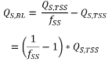

### Clustering Drivers of Erosion and Sediment Transport

Previously regional delineations of geomorphic provinces were applied to delineate areas with similar sediment yields based on an expert based analysis of factors linking to catchment-scale erosion (Kondolf et al., 2014; Minear and Kondolf, 2009) and this information was subsequently used to inform hydropower planning (Schmitt et al., 2019). Even a first review of available data and their gradient in the country reveals that geomorphic covariates that link to sediment and river processes show strong gradients throughout the country. For Nepal, results from a global erosion model (Borrelli et al., 2017) might enable direct modeling of sediment loads without the need to extrapolate sediment loads from expert delineations of geomorphic provinces.

However, also in the Nepalese context a geomorphic zonation might be useful to inform river management strategies that consider for the geomorphic setting of rivers. In contrast to previous approaches for geomorphic zonation that were mostly based on a manual delineation and expert knowledge, we herein use a data-driven approach based on a k-means clustering algorithm. This innovation is possibly useful in the context of Nepal, where despite clear gradients in geomorphic covariates, there might be rapid transitions and sharp boundaries between driver values that would be hard to capture using a manual delineation. For the k-means clustering we used six geomorphic covariates that are listed in Table 1. For the clustering, we divided the area of interest in 1360 small (around 30 km2 mean area) subcatchments and aggregated each covariate for each subcatchment. For the clustering, the resulting six covariate vectors were normalized to zero mean and unit variance. The result of the clustering approach are (1) each subcatchment is assigned to a specific geomorphic cluster that can be analysed on a map (2) the centers of all cluster can be analysed with regard to their mean value to understand if their characteristics coincide with our conceptual understanding of geomorphic processes in Nepal.

|  |  |  |
| --- | --- | --- |
| **Table 1: Covariates for deriving geomorphic clusters** | | |
| Covariate | Data source | Link to sediment transport and river processes |
| Precipitation | Aphrodite | Precipitation drives hillslope erosion and mass movements |
| Elevation | ALOS digital elevation model | Relief and slope are indicators for uplift and connectivity between channels and slopes |
| Gradient |
| Relief |
| Erodibility/k-factor | SOTER/ISRIC | The k factor is a composite indicator considering for soil properties. Note that the K-Factor is not specific for Nepal, but derived from a global dataset, which in turn is based on an interpolation. |
| Distance to major faults | ICIMOD | Distance to faults is a key control behind sediment transport in rivers (grainsize, total load in Nepal), even though the mechanisms are not well understood (Attal and Lavé, 2006) |
|  |  |  |

As an additional validation, we propose an approach that links geomorphic provinces to observed sediment loads. The original approach by e.g., Minear and Kondolf (2009) proposed to calculate the (unmonitored) sediment load in a point of interest from the geomorphic provinces in its drainage area, and the sediment yields of these geomorphic provinces such that

𝑄𝑆 = 𝑦1 ∗ 𝐴1 + ⋯ + 𝑦𝑛 ∗ 𝐴𝑛

I.e., the sediment load is determined as the sediment yields (𝑦1, … , 𝑦𝑛) multiplied with the area of each geomorphic province 𝐴𝑖 … 𝐴𝑛 draining to the point of interest.

Here we propose to inverse this approach, based on the observed sediment loads. Similar to above, we can define the sediment load at a gauging station as

𝑄𝑆(𝑔) = 𝑦1 ∗ 𝐴1(𝑔) + ⋯ + 𝑦𝑛 ∗ 𝐴𝑛(𝑔)

i.e., as the sum of product of unknown sediment yields of geomorphic provinces (𝑦1 … 𝑦𝑛) and the part of a gauges drainage area belonging to each province. Based on the available twelve gauges, we can formulate an equation system of the form

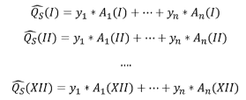

Each line describes the modelled sediment load, , at one of the 12 gauging stations (denoted by roman numerals) as a function of how a station’s drainage area is divided between geomorphic provinces and the yield of each geomorphic provinces. Based on that equation system we can try to identify if there is a set of values for sediment yields that e.g., the root mean square error so that



As mentioned above, the thus derived sediment yields can be used for cross-validation with the results of the global erosion model as well as for checking the plausibility of the geomorphic clustering.

# Results

## Magnitude and uncertainty of suspended sediment transport

This analysis is based on gauged sediment data for 16 stations throughout Nepal (Figure 3), however, for most of the discussion we focus on the 12 stations reported by Anderman et al. (2012) as they provide coverage of the entire country. The additional stations provided by Vogl, Schmitt et al. (2019) are a useful independent validation, but are discussed separately, because they cover only the Kaligandaki basin, and at much later time (2018/2019) than most of the DHM data presented by Anderman et al. (2012). The sediment data from DHM mostly only comprise few years of data for each station, sometimes reaching back to the 1970s and 1980s (Figure 5, grey). The longer availability of discharge data (Figure 5, blue) for most stations allowed Anderman et al. (2012) to extrapolate sediment loads for years in which there were discharge but no sediment data available by using a rating curve approach (see Methods). However, it should be noted that such an extrapolation is subject to major uncertainty, e.g., static rating curves will greatly over or underestimate sediment load if there is a shift in sediment supply over time. The period of time best covered by coinciding sediment and discharge data falls into the 1970s and 1980s, and the sediment loads calculated are most representative for this period of time.

Table 2 and Figure 4 report the suspended sediment loads and yields for all available stations . Sediment export captured by the available stations covers the majority of major rivers in Nepal, with the exception of the Mahakali river in the far west (Figure 3). Based on the available data, the three major rivers of the country (Karnali, Narayani, Sapta Koshi) stand out in terms of total suspended load with an estimated 109 Mt/yr (Karnali), 127 Mt/yr (Narayani) and 128 Mt/yr (Sapta Koshi). Sediment yields are 2385 Mt/km2/yr for the Karnali, 3975 Mt/km2/yr for the Narayani and 2385 Mt/km2/yr for the Sapta Koshi. The distribution of yields and loads is in agreement with the understanding of processes creating sediment in the Himalayas as high yields from the Narayani coincide with unusually high rates of uplift and precipitation around the Annapurna Massif, which drains towards the Narayani. For smaller lowland basins, variability in sediment yields is very high. Heterogeneity in sediment yield from smaller basins is high. Some of the southern basins that drain the Siwaliks have rather low sediment yields (Saradha: 530 t/km2/yr, Kankai Mai: 1325 t/km2/yr, Bagmati: 1590 t/km2/yr), while the Rapti and upper Rapti have high yields of 2650 t/km2/yr and 5035 t/km2/yr, the latter is the highest yield amongst all basins. The Rapti River also experiences a downstream decrease in sediment load. This could indicate that there is some deposition occurring as soon as the river leaves the Siwalik mountains and enters the Gangetic plains. Such processes are documented along the Koshi River, too, where they lead to significant challenges for water and floodplain management (Sinha et al., 2019).

There are also some remarkable outliers amongst the rivers draining the high Himalayas. Notably, suspended sediment yield and load from the small and very steep Bhote Khoshi catchment is only 0.3 Mt/yr or 265 t/km2/yr. Also the Trishuli catchment which is adjacent to the Bhote Khoshi in the west has some rather low loads and yields (3.5 Mt/yr, 795 t/km2/yr). Most remarkably, the sediment yields from the upper Karnali Basin (1060 t/km2/yr) are more similar to the small lowland basins, resulting in a rather low sediment load (22.4 Mt/yr). This would indicate that most of the sediment exported from the Karnali originates from the lower parts of the basin and notably from the two major tributaries, the Seti and Bheri rivers.

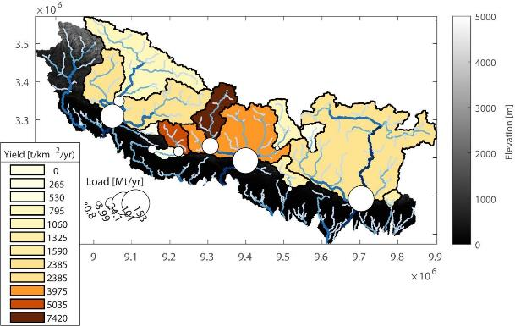

Figure : Sediment yield and load of the major rivers of Nepal. Location of available sediment data based on the gauging stations reported by Anderman et al. (2012). Thick black lines represent the area contributing to each gauging station. Colors represent the sediment yield from the contributing area of each gauge and the marker size indicates the sediment flux.

|  |
| --- |
| **Table 2: Suspended sediment yields and loads for gauging stations in Nepal.** |
|  | |  |  |

|  |  |  |  |  |  |  |  |  |  |  |  |  |  |  |  |  |  |  |  |  |  |  |  |  |  |  |  |  |  |  |  |  |  |  |  |  |  |  |  |  |  |  |  |  |  |  |  |  |  |  |  |  |
| --- | --- | --- | --- | --- | --- | --- | --- | --- | --- | --- | --- | --- | --- | --- | --- | --- | --- | --- | --- | --- | --- | --- | --- | --- | --- | --- | --- | --- | --- | --- | --- | --- | --- | --- | --- | --- | --- | --- | --- | --- | --- | --- | --- | --- | --- | --- | --- | --- | --- | --- | --- | --- |
| Station | |  | 1970 | 1971 | 1972 | 1973 | 1974 | 1975 | 1976 | 1977 | 1978 | 1979 | 1980 | 1981 | 1982 | 1983 | 1984 | 1985 | 1986 | 1987 | 1988 | 1989 | 1990 | 1991 | 1992 | 1993 | 1994 | 1995 | 1996 | 1997 | 1998 | 1999 | 2000 | 2001 | 2002 | 2003 | 2004 | 2005 | 2006 | 2007 | 2008 | 2009 | 2010 | 2011 | 2012 | 2013 | 2014 | 2015 | 2016 | 2017 | 2018 | 2019 |
| 1005 | Jomsom | Q |  |  |  |  |  |  |  |  |  |  |  |  |  |  |  |  |  |  |  |  |  |  |  |  |  |  |  |  |  |  |  |  |  |  |  |  |  |  |  |  |  |  |  |  |  |  |  |  |  | |
| CS |  |  |  |  |  |  |  |  |  |  |  |  |  |  |  |  |  |  |  |  |  |  |  |  |  |  |  |  |  |  |  |  |  |  |  |  |  |  |  |  |  |  |  |  |  |  |  |  |  | |
| 1004 | Tatopani | Q |  |  |  |  |  |  |  |  |  |  |  |  |  |  |  |  |  |  |  |  |  |  |  |  |  |  |  |  |  |  |  |  |  |  |  |  |  |  |  |  |  |  |  |  |  |  |  |  |  | |
| CS |  |  |  |  |  |  |  |  |  |  |  |  |  |  |  |  |  |  |  |  |  |  |  |  |  |  |  |  |  |  |  |  |  |  |  |  |  |  |  |  |  |  |  |  |  |  |  |  |  | |
| 1001 | Mangalghat | Q |  |  |  |  |  |  |  |  |  |  |  |  |  |  |  |  |  |  |  |  |  |  |  |  |  |  |  |  |  |  |  |  |  |  |  |  |  |  |  |  |  |  |  |  |  |  |  |  |  | |
| CS |  |  |  |  |  |  |  |  |  |  |  |  |  |  |  |  |  |  |  |  |  |  |  |  |  |  |  |  |  |  |  |  |  |  |  |  |  |  |  |  |  |  |  |  |  |  |  |  |  | |
| 1006 | Modi Beni | Q |  |  |  |  |  |  |  |  |  |  |  |  |  |  |  |  |  |  |  |  |  |  |  |  |  |  |  |  |  |  |  |  |  |  |  |  |  |  |  |  |  |  |  |  |  |  |  |  |  | |
| CS |  |  |  |  |  |  |  |  |  |  |  |  |  |  |  |  |  |  |  |  |  |  |  |  |  |  |  |  |  |  |  |  |  |  |  |  |  |  |  |  |  |  |  |  |  |  |  |  |  | |
| 1002 | Nayapul | Q |  |  |  |  |  |  |  |  |  |  |  |  |  |  |  |  |  |  |  |  |  |  |  |  |  |  |  |  |  |  |  |  |  |  |  |  |  |  |  |  |  |  |  |  |  |  |  |  |  | |
| CS |  |  |  |  |  |  |  |  |  |  |  |  |  |  |  |  |  |  |  |  |  |  |  |  |  |  |  |  |  |  |  |  |  |  |  |  |  |  |  |  |  |  |  |  |  |  |  |  |  | |
| 0 | Bhote Koshi | Q |  |  |  |  |  |  |  |  |  |  |  |  |  |  |  |  |  |  |  |  |  |  |  |  |  |  |  |  |  |  |  |  |  |  |  | | |  |  |  |  |  |  |  |  |  |  |  |  |  |
| CS |  |  |  |  |  |  |  |  |  |  |  |  |  |  |  |  |  |  |  |  |  |  |  |  |  |  |  |  |  |  |  |  |  |  |  | | |  | |  |  |  |  |  |  |  |  |  |  |  |
| 240 | Upper Karnali | Q |  |  |  |  |  |  | | | | |  | | | | | | | | | | | | | | | | | | | | | | | | | | |  |  |  |  |  |  |  |  |  |  |  |  |  |
| CS |  |  |  |  |  |  | | | | |  |  |  |  |  |  |  |  |  |  |  |  |  |  |  |  |  |  |  |  |  |  |  |  |  |  |  |  |  |  |  |  |  |  |  |  |  |  |  |  |
| 280 | Karnali | Q |  |  |  |  | |  | |  | | |  | | | | | | | | | | | | | | | | | | | | | | | | | | |  |  |  |  |  |  |  |  |  |  |  |  |  |
| CS |  |  |  |  | |  |  |  | | |  |  |  |  |  |  |  |  |  |  |  |  |  |  |  |  |  |  |  |  |  |  |  |  |  |  |  |  |  |  |  |  |  |  |  |  |  |  |  |  |
| 286 | Saradha | Q |  |  |  |  |  |  |  | | |  | | | | | |  | | |  | | | | | | | | | | | | | | | | | | |  |  |  |  |  |  |  |  |  |  |  |  |  |
| CS |  |  |  |  |  |  |  | | |  |  |  |  |  |  |  | | |  |  |  |  |  |  |  |  |  |  |  |  |  |  |  |  |  |  |  |  |  |  |  |  |  |  |  |  |  |  |  |  |
| 360 | Rapti | Q |  |  |  |  |  |  |  |  |  |  |  |  |  |  |  |  |  |  | |  | | | | | | | | | | | | | | | | | |  |  |  |  |  |  |  |  |  |  |  |  |  |
| CS |  |  |  |  |  |  |  |  |  |  |  |  |  |  |  |  |  |  | |  |  |  |  |  |  |  |  |  |  |  |  |  |  |  |  |  |  |  |  |  |  |  |  |  |  |  |  |  |  |  |
| 410 | Kali Gandaki | Q |  |  |  |  |  |  |  |  |  |  | |  | | | | | |  | |  |  |  | | | | |  |  |  |  |  |  |  |  |  |  |  |  |  |  |  |  |  |  |  |  |  |  |  |  |
| CS |  |  |  |  |  |  |  |  |  |  | |  |  |  |  |  |  |  | |  |  |  |  |  |  |  |  |  |  |  |  |  |  |  |  |  |  |  |  |  |  |  |  |  |  |  |  |  |  |  |
| 447 | Trishuli | Q |  |  |  |  |  |  |  |  |  |  |  | | | | | | | | | | | | | | | | | | | | | | | | | | |  |  |  |  |  |  |  |  |  |  |  |  |  |
| CS |  |  |  |  | | | |  |  |  |  |  |  |  |  |  |  |  |  |  |  |  |  |  |  |  |  |  |  |  |  |  |  |  |  |  |  |  |  |  |  |  |  |  |  |  |  |  |  |  |
| 450 | Narayani | Q |  |  |  |  | | |  | |  |  |  | | | | |  | |  | | | | | |  |  | | | | | | |  | | |  | | |  |  |  |  |  |  |  |  |  |  |  |  |  |
| CS |  |  |  |  |  |  |  | |  |  |  |  |  |  |  |  | |  |  |  |  |  |  |  |  |  |  |  |  |  |  |  | | |  |  |  |  |  |  |  |  |  |  |  |  |  |  |  |  |
| 589 | Bagmati | Q |  |  |  |  |  |  |  |  |  |  |  |  |  |  |  |  |  |  |  |  |  |  |  |  |  |  |  |  |  |  |  |  | | |  | | |  |  |  |  |  |  |  |  |  |  |  |  |  |
| CS |  |  |  |  |  |  |  |  |  |  |  |  |  |  |  |  |  |  |  |  |  |  |  |  |  |  |  |  |  |  |  |  | | |  |  |  |  |  |  |  |  |  |  |  |  |  |  |  |  |
| 695 | Sapta Koshi | Q |  |  |  |  |  |  |  |  | | | | | | | | | |  |  | | | | | | | | | | |  |  |  | | |  |  |  |  |  |  |  |  |  |  |  |  |  |  |  |  |
| CS |  |  |  |  |  |  |  |  |  |  |  |  |  |  |  |  |  |  |  |  |  |  |  |  |  |  |  |  |  |  |  |  | | |  |  |  |  |  |  |  |  |  |  |  |  |  |  |  |  |
| 795 | Kankai Mai | Q |  |  |  |  |  |  |  |  |  |  |  |  |  |  |  |  |  |  |  |  |  |  |  |  |  |  |  |  |  |  |  |  | | |  | | |  |  |  |  |  |  |  |  |  |  |  |  |  |
| CS |  |  |  |  |  |  |  |  |  |  |  |  |  |  |  |  |  |  |  |  |  |  |  |  |  |  |  |  |  |  |  |  | | |  |  |  |  |  |  |  |  |  |  |  |  |  |  |  |  |

Figure : Temporal coverage of sediment and discharge data in Nepal

## Estimating bedload transport rates

According to the suspended/bedload load model (Methods), bedload transport in the rivers of Nepal can make out a significant fraction of total loads. For example, for the three large basins Karnali, Narayani and Koshi the modelled suspended load fraction is around 90 %, with the (unmonitored) remainder being bedload. Because of the large sediment loads, even 10 % bedload amount to substantial quantities (Figure 6).

For example, the modelled bedload at Karnali Chisapani is around 26 Mt/yr and thus substantially more than the total load from some smaller basins in the country. There are no consistent bedload measurements available for comparison. However, there is relevant evidence that Nepal’s rivers carry a significant bedload fraction ranging from pebbles to small boulder beyond the Siwaliks and deposit them eventually in the Gangetic plains.

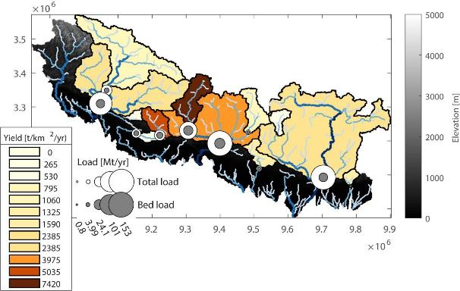

Figure : Modelled bedload and total load in the major rivers of Nepal. Bedload was modelled from observed suspended load and total load is the sum of both

## Comparing DHM and radio-nuclide data for the Karnali basin

Suspended sediment loads and yields for rivers in Nepal vary widely. And while the variation in values reported by DHM for the three major river systems (Karnali, Narayana, Koshi) seem to be mostly consistent, there is significant variability amongst smaller rivers and in the patterns of sediment origin within the major basins. Of notable importance for this study is the sediment origin in the Karnali basin, where DHM data indicate that most of the sediment is derived from the Seti and Bheri rivers. It should also be noted that the suspended sediment load that is reported for the Karnali river by DHM (around 110 Mt/yr) and the calculated bedload (around 20 Mt/yr) is notably lower than the sediment load of up to 260 Mt/yr that is cited, e.g., in the EIA for the Karnali Chisapani Dam[3] (p. 63). This EIA also points to the high uncertainty in DHM’s data for the Karnali that date back to the 1970s (Figure 5). However, the 260 Mt/yr estimate is itself based on a three-month sampling campaign that was then extrapolated.

Some independent studies are available for the Karnali Basin (Ojha et al., 2019; Beek et al., 2016). While originally intended for studying long-term geomorphology, these data provide valuable information for river management. Specifically, Ojha et al. (2019) report denudation rates based on cosmogenic nuclides (see methods for a short introduction into the conversions) at Karnali ferry (approximately the location of the upper Karnali gauging station), a location downstream of that, but before the confluence of the Seti, Bheri, and Karnali. Importantly, they also report on denudation rates for the points within the Seti and Bheri rivers that are otherwise ungauged.

Based on these data, the long-term sediment load at Karnali ferry is 48 Mt/yr, which increases to 59 to the more downstream location on the Karnali. The Seti river contributes 11 Mt/yr and the Budhiganga, a left-hand tributary to the Bheri adds another 12 Mt/yr (the Budhiganga is notable for the extremely high sediment yields of nearly 10,000 t/km2/yr). The Bheri river contributes around 16 Mt/yr. Thus, the total sediment load of the lower Karnali can be estimated from the sum of these contributions as 59 + 11 + 12 + 16 Mt/yr = 98 Mt/yr. Based on the uncertainty intervals given by Ojha et al. (2019), the lower and upper bounds of Ohja et al’s sediment budget are 71 to 126 Mt/yr. Thus the 110 Mt/yr total load that are estimated from the suspended load measured by DHM and the data by Ojha et al. are largely in agreement.

However, it should be noted that the area covered by the measurements of Ojha does not cover the entire drainage area of the DHM Karnali station (and for that matter of the Karnali Dam). By using the mean sediment yields as reported by Ohja et al. for all subbasins, and extrapolating that yield to the entire basin of the Karnali, we estimate a total long-term sediment export of 111 – 160 Mt/yr. Also, Van der Beck et al. (2016) report denudation rates from the upper and middle Karnali in the range of 0.5 – 2.2 mm/yr, resulting in an average of around 2700 t/km2/yr, which using a drainage area of 60,000 km2 for the whole Karnali would equal a total sediment export of 130 Mt/yr. It should be noted that geochemical erosion estimates by Ohja et al. and van der Beck et al. might underestimate a possible contribution from land degradation and soil erosion. However, the contribution of these anthropic processes to the overall sediment budget is probably comparably low given the very high natural rates of sediment transport and erosion.

To conclude, available evidence from geochemical measures and in-stream observations point to a sediment export of around 130 Mt/yr from the Karnali basin. However the very low sediment loads from the upper Karnali observed in the DHM data (Andermann et al., 2012) are not in good agreement with other lines of evidence, and very high estimated loads at the Karnali-Chisapani dam site (260 Mt/yr) seem rather to be outliers then a representative long term average.

Thus, while it is possible that 260 Mt/yr are within the expected range of natural variability for the Karnali system, the long term average might be lower. Such discrepancies and unexpected patterns in the data show that more sampling data would be urgently needed to better constrain sediment origins in the Karnalii.

## Applicability of global erosion models to Nepal

Sediment exports from Nepal’s major rivers seem to be reasonably well constrained However, what is evident from Figures 1 – 4 is that smaller basins and more upstream parts of the river are barely monitored. E.g., even the three major basins have only 2 stations each, typically one at the transition from the Siwaliks to the Gangetic plains and one more upstream. Thus, sediment origins within these basins and sediment transport in tributaries and the upper parts of each basin is basically unknown. These rates of upstream transport would however be of great interest for management, e.g., to understand how upstream hydropower might interfere with downstream river processes and how much hydroelectric facilities might be impacted by high sediment loads and we propose that sediment transport in unmonitored basins might at least be estimated from global erosion models (Borrelli et al., 2017).

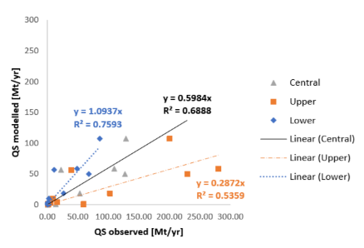

Figure : Comparison of observed and modelled suspended sediment transport. Modelled results are derived by accumulating results from a global erosion model for the drainage area of all gauging stations. Model results are compared separately to the high (orange), central (grey) and low (blue) estimates of at-station load proposed by Andermann et al. (2018)

Indeed, results from the global erosion model are able to characterize suspended sediment transport reasonably well (Figure 7). Modelled data underestimate central estimates of at-station sediment load, as indicated by the slope of the best-fit line being smaller than one. Despite this systematic error, the global model represents 70 % of the observed variance (R2=0.68). Model quality increases respectively decreases when comparing the lower and the upper confidence intervals of observed data to the model. There is basically no systematic error when comparing model results to the observations (slope = 1.1) and the model explains 76 % of observed variance. In contrast, for the upper confidence interval of observations, the model significantly underestimates suspended loads (slope 0.29) and explains only 54 % of observed variance.

Fitting a linear model between central estimates of observed loads and model results and comparing the resulting model to the uncertainty in data shows that results are within the confidence interval of observations, especially for the larger basins (Figure 8). Thus, while results from the global model are not perfectly correlated to observations model results fall within a plausible range around the central estimates of observation.

A common claim in modeling erosion is that predicting sediment loads from smaller basins is much harder than modeling erosion and transport in larger basins. This is mostly because smaller basins might have a much greater variability in sediment generating processes that are not represented in common erosion models. That finding holds true to a certain extent in Nepal, too. When comparing modelled sediment loads to observations to a subset of smaller basins (<10,000 km2), we find that the model can describe less of the observed variance (R2 = 0.58 compared to an R2 of 0.68 for all stations) and that the model leads to a greater underestimation of sediment loads (regression slope is 0.6 for all stations but only 0.34 for small stations). This greater underestimation is in accordance with our understanding of sediment generation in the Himalayas, where sediment budgets of smaller catchments are likely dominated by glacial sediment generation and processes such as landslides and rockfalls that are not captured by a USLE based model. However, as the model still explains a decent amount of variance between the smaller basins, we propose that it remains applicable to capture variability in sediment transport even across smaller, more uphill rivers.

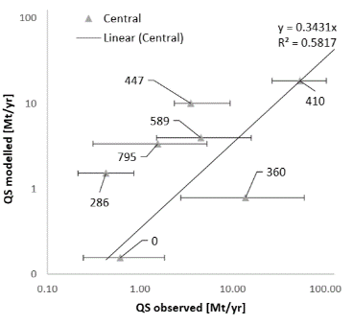

Figure : Comparing model and data uncertainty. Sediment load predicted by the global model falls within the range of observational uncertainty for many stations (error bars indicate the upper and lower confidence intervals in observed suspended sediment loads). Markers indicate the central estimate of at-station sediment loads reported by Andermann et al. 2012.

## Modeling suspended and bedload transport in Nepal

Thus, overall results of the global erosion model are in good accordance with observed sediment loads and accumulating results of the global erosion model throughout the network is a good way forward to derive spatially fully distributed estimates of suspended sediment transport (Figure 9). We then modelled the ratio of suspended sediment to total load (𝑓𝑆𝑆, see Methods) throughout the network. While this calculation makes suspended load (and then also bedload) a function of drainage area only, it reproduces patterns that are mostly in agreement with our understanding of bedload dynamics (Figure 10). Notably, the rate of suspended load is lowest in small tributaries (magenta in Figure 10). That means that sediment transport in those first and second order rivers is dominated by bedload. More downstream, sediment transport is instead dominated by suspended sediment (yellow in Figure 10). However, even with that downstream decrease in the ration of bedload to total load, total bedload increases downstream (magenta in Figure 11).

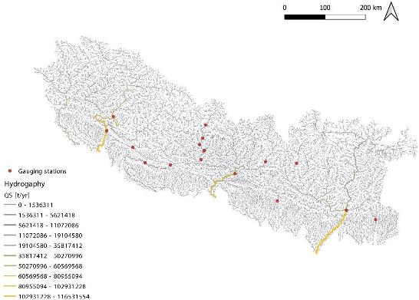

Figure : Suspended sediment load in the rivers of Nepal. Suspended sediment loads were modelled by accumulating results of a global erosion model (Borrelli et al., 2017) through the hydrographic network (Grill et al., 2019).

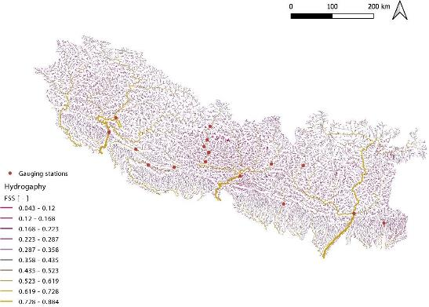

Figure : Modelled ratio of suspended to total load in the rivers of Nepal.

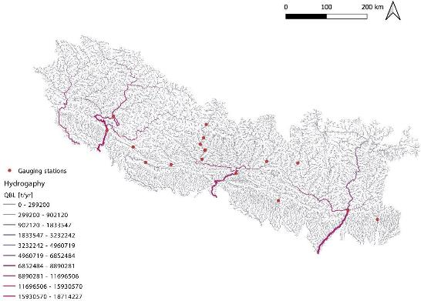

Figure : Modelled bedload transport in the rivers of Nepal.

### Clustering Drivers of Erosion and Sediment Transport

The geomorphic clustering identified five geomorphic clusters from the multivariate input data, with each cluster identifying groups of small sub-catchment that are similar in the multivariate space of geomorphic parameters (Figure 12). The geomorphic clusters are mostly spatially cohesive, i.e., certain clusters cover certain parts of the study area and divisions between clusters follow the north south gradient in most geomorphic covariates (Figure 2).

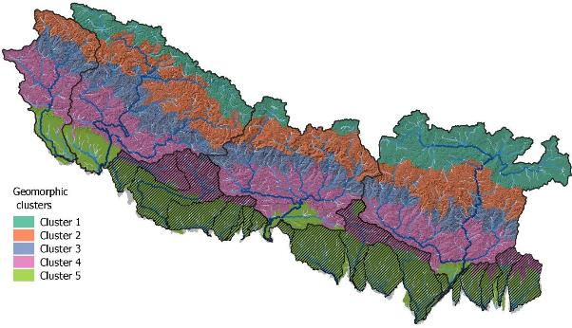

Figure : Geomorphic clustering of the study area. The geomorphic clustering approach identified five geomorphic provinces using a k-means clustering approach and a set six geomorphic covariates.

|  |  |  |  |  |  |  |
| --- | --- | --- | --- | --- | --- | --- |
| Characteristics of geomorphic clusters. Listed values are the center points of each cluster in the SIX DIMENSIONAL geomorphic covariate space | | | | | | |
|  | **Precipitation**  **[mm]** | **Elevation**  **[m]** | **Gradient**  **[Deg]** | **Relief**  **[m]** | **K Factor**  **[m]** | **Distance to**  **faults [m]** |
| **GeoCluster 1** | 91 | 4908 | 15 | 1103 | 0.021 | 103251 |
| **GeoCluster 2** | 417 | 4600 | 27 | 2336 | 0.018 | 59701 |
| **GeoCluster 3** | 2106 | 2781 | 30 | 2415 | 0.034 | 25065 |
| **GeoCluster 4** | 1838 | 1239 | 22 | 1346 | 0.038 | 10064 |
| **GeoCluster 5** | 1512 | 167 | 3 | 160 | 0.036 | 40462 |

Each cluster has specific geomorphic characteristics (Table 3). Cluster 1 includes very high (mean elevation 4900 m) and very dry (mean precipitation 91 mm) high valleys of the Tibetan plateau which are relatively low in gradient and relief. Cluster 2 includes areas directly north of the main chain of High Himalayan summits. Precipitation is also low, but relief and gradient are higher than for cluster 2. The very low k factor results from a prevalence of bare rock, permanent snow and glaciers for which the k factor is zero. Cluster 3 includes the steepest slopes and highest relief, as well as the highest precipitation, which coincides with the gorges that the major river cut through the high Himalayas. Cluster 4 delineates the area of the low Himalayas and the Siwaliks, precipitation and relief are the second highest amongst all clusters and the erodibility is highest. Cluster 4 also has the least distance to the major fault lines. Cluster 5 coincides mostly with the Gangetic plains, i.e., low gradient areas at low elevation.

TABLE * NEEDS TO BE REPLACED WITH THE TABEL INSERTED BELOW!

Trying to determine the geomorphic clusters using a minimization approach leads to inconclusive results. Solving the equation system in an unconstraint approach leads to a minimal error when a zero yield is assigned to geomorphologic clusters 1 and 2. This indicates that problem is poorly constraint as the sediment yield from the Himalayan plateau is basically unmonitored (Figure 3). However, the assigned values for cluster 3 – 5 are sensate in the sense that there is a decreasing trend in sediment yields from cluster three to cluster 1, which is assigned the lowest sediment yield.

|  |  |  |  |  |  |  |  |  |  |  |  |  |  |
| --- | --- | --- | --- | --- | --- | --- | --- | --- | --- | --- | --- | --- | --- |
| **Table 3: Unconstraint optimization of sediment yields. An optimization algorithm is applied to find combination of sediment yields (top rows) that minimize the sum of square errors between observed and modelled sediment loads. Sediment loads are modelled by multiplying sediment yields with the contributing area of each station that falls within a geomorphic (GM) cluster.** | | | | | | | | | | | | | |
|  | ***y(1)***  ***[t/km2/yr]*** | | ***y(2)***  ***[t/km2/yr]*** | | | ***y(3)***  ***[t/km2/yr]*** | ***y(4)***  ***[t/km2/yr]*** | | | ***y(5)***  ***[t/km2/yr]*** | |  | |
|  | | 0.00 | | 0.00 | | 6237.99 | | 4811.95 | 1210.86 | |  | |  | | |
|  | | ***GMClust_1*** | | ***GMClust_2*** | | ***GMClust_3*** | | ***GMClust_4*** | ***GMClust_5*** | | ***QS_observed*** | | ***QS_modelled*** | | |
| ***Name*** | | | | | ***km2*** | | | | | ***Mt/yr*** | | | | |
| ***Bhote Koshi*** | | 876.39 | | 1521.92 | | 287.37 | | 0.00 | 0.00 | | 0.61 | | 1.79 | | |
| ***Upper Karnali*** | | 11147.37 | | 11153.28 | | 4654.32 | | 628.08 | 0.00 | | 22.39 | | 32.06 | | |
| ***Karnali*** | | 1292.13 | | 8423.40 | | 8596.47 | | 13825.93 | 0.00 | | 109.63 | | 120.15 | | |
| ***Saradha*** | | 0.00 | | 0.00 | | 0.00 | | 1247.51 | 0.00 | | 0.43 | | 6.00 | | |
| ***Upper Rapti*** | | 0.00 | | 0.00 | | 165.86 | | 4447.85 | 0.00 | | 18.37 | | 22.44 | | |
| ***Rapti*** | | 0.00 | | 0.00 | | 0.00 | | 850.64 | 1130.87 | | 13.77 | | 5.46 | | |
| ***Kali Gandaki*** | | 2246.95 | | 3124.02 | | 2572.33 | | 1067.33 | 0.00 | | 53.20 | | 21.18 | | |
| ***Trishuli*** | | 1113.63 | | 3839.21 | | 1009.60 | | 5.72 | 0.00 | | 3.52 | | 6.33 | | |
| ***Narayani*** | | 0.00 | | 6667.38 | | 5894.63 | | 13286.46 | 16.63 | | 127.21 | | 100.72 | | |
| ***Bagmati*** | | 0.00 | | 0.00 | | 0.00 | | 3060.27 | 513.04 | | 4.53 | | 15.35 | | |
| ***Sapta Koshi*** | | 25432.51 | | 15166.15 | | 9022.01 | | 17046.23 | 21.48 | | 128.85 | | 138.33 | | |
| ***Kankai Mai*** | | 0.00 | | 0.00 | | 0.00 | | 1172.56 | 274.88 | | 1.55 | | 5.98 | | |

# Conclusion

Complexity of sediment dynamics of rivers of Nepal is well documented by studies on individual rivers. Complexity is driven by extreme gradients in topography, precipitation and tectonic forcing that results in a great heterogeneity in sediment supply, sediment transport, and fluvial forms and processes. Understanding that heterogeneity on a country level is hampered by the scarce observational record in terms of sediment sampling. However, that scarcity, which could be a great limitation to river and water resources management in the country is somewhat alleviated by the relative abundance of scientific studies aiming to understand geomorphology and earth surface dynamics in the Himalayas over geologic time scales. Our review of available studies shows that these studies together with the few and outdated data from DHM allow to paint a relatively consistent image of sediment export from the rivers of Nepal to the Ganga system.

While DHM and other data are mostly limited to far downstream station analyzing these data also enabled to validate the applicability of global erosion data as a proxy for sediment transport in unmonitored rivers. Given that the model does cover only sheet and rill erosion, and thus omits many processes that are known to be relevant sources of sediment in the Himalayas, e.g., glaciers, mass movements and landslides driven by precipitation and earthquakes, river bed and bank erosion, and sediment related to massive glacial outburst floods (GLOFs) the overall agreement between model results and observations is rather good. In fact, the ability of the model to represent observed sediment transport is comparable to previous global applications (Grill et al., 2019). The model also represents a satisfying amount of variability in between different rivers. Comparing modelled and observed data also shows that spatial patterns in model error coincide with our understanding of sediment transport in the Himalayas. For example, underestimation of suspended sediment transport increases for smaller rivers, where sediment transport is likely dominated by processes that are not considered in the erosion model.

The good agreement of this sediment supply model and the data is especially important for rivers in Nepal, where sediment transport is likely driven by sediment supply rather than by transport capacity, i.e., in the high gradient high energy rivers of the Himalayas most of the material that is supplied by hillslope processes can be transported downstream. This limits the applicability of approaches that use transport capacity to estimate total transport rates (Schmitt et al., 2018, 2016).

Based on these results we also extrapolated suspended sediment transport. It should be noted that this model is derived from a regression approach derived from global data and that there are no field data available for comparison. Nonetheless, the overall pattern of modelled bedload transport seems sensate. Bedload transport is possibly of great importance for river management in Nepal, and could possibly impact hydropower development, which in turn would alter bedload dynamics and geomorphic processes throughout Nepal. Even in larger rivers of Nepal bedload transport cannot be ignored because even the largest rivers carry a major amount of bedload to the Gangetic plains, which is different from most geographies, where bedload transport of large rivers is small.

Previously it has been shown that hydromorphologic properties of rivers can be analyzed with data- driven approaches to define generalized hydromorphologic classes of rivers that relate to certain forms and processes (Schmitt et al., 2014). Here, we demonstrate for the first time that a similar approach can also be used to delineate geomorphic provinces. This approach does not replace possibly existing previous expert delineations of geomorphologic zones, but is rather complementary, being based on globally available data and a reproducible numeric analysis. Cross-validating geomorphic provinces and gauged sediment data was partially inhibited by the uneven spatial distribution of gauged data. However, the geomorphic provinces seem otherwise sensate and could support rapid assessments of river status and management challenges that relate to the specific geomorphic setting of a specific river.

To conclude, sediment transport in most rivers of Nepal is much larger than that of rivers of similar size in different geographies. This makes understanding sediment dynamics an important issue for river management. Sediment management in Nepal is hampered by data scarcity, especially when it comes to processes such as landslides and bedload transport that are of utmost importance to understand overall sediment dynamics, and links between sediment, infrastructure and livelihoods. Despite those limitation, we herein showed that the available evidence from different independent sources can be used to derive a consistent representation of sediment transport in Nepal’s river. While uncertainty in these modelled data should be acknowledged for management applications, the data herein can be used to constrain sediment related challenges in water management for large basins, such as the Karnali, or even on a national scale.

# References

Andermann, C., Crave, A., Gloaguen, R., Davy, P., Bonnet, S., 2012. Connecting source and transport: Suspended sediments in the Nepal Himalayas. Earth and Planetary Science Letters 351–352, 158–170. https://doi.org/10.1016/j.epsl.2012.06.059

Attal, M., Lavé, J., 2009. Pebble abrasion during fluvial transport: Experimental results and implications for the evolution of the sediment load along rivers. J. Geophys. Res. 114, F04023. https://doi.org/10.1029/2009JF001328

Beek, P. van der, Litty, C., Baudin, M., Mercier, J., Robert, X., Hardwick, E., 2016. Contrasting tectonically driven exhumation and incision patterns, western versus central Nepal Himalaya. Geology 44, 327–330. https://doi.org/10.1130/G37579.1

Borrelli, P., Robinson, D.A., Fleischer, L.R., Lugato, E., Ballabio, C., Alewell, C., Meusburger, K., Modugno, S., Schütt, B., Ferro, V., Bagarello, V., Oost, K.V., Montanarella, L., Panagos, P., 2017. An assessment of the global impact of 21st century land use change on soil erosion. Nature Communications 8, 2013. https://doi.org/10.1038/s41467-017-02142-7

Chhetry, B., Rana, K., 2015. Effect of Sand Erosion on Turbine Components: A Case Study of Kali Gandaki “A” Hydroelectric Project (144 MW), Nepal. Hydro Nepal Journal of Water Energy and Environment 17. https://doi.org/10.3126/hn.v17i0.13270

Godard, V., Bourlès, D.L., Spinabella, F., Burbank, D.W., Bookhagen, B., Fisher, G.B., Moulin, A., Léanni, L., 2014. Dominance of tectonics over climate in Himalayan denudation. Geology 42, 243–246. https://doi.org/10.1130/G35342.1

Goodbred, S.L., Kuehl, S.A., 1999. Holocene and modern sediment budgets for the Ganges- Brahmaputra river system: Evidence for highstand dispersal to flood-plain, shelf, and deep- sea depocenters. Geology 27, 559–562. https://doi.org/10.1130/0091- 7613(1999)027<0559:HAMSBF>2.3.CO;2

Grill, G., Lehner, B., Thieme, M., Geenen, B., Tickner, D., Antonelli, F., Babu, S., Borrelli, P., Cheng, L., Crochetiere, H., Macedo, H.E., Filgueiras, R., Goichot, M., Higgins, J., Hogan, Z., Lip, B., McClain, M.E., Meng, J., Mulligan, M., Nilsson, C., Olden, J.D., Opperman, J.J., Petry, P., Liermann, C.R., Sáenz, L., Salinas-Rodríguez, S., Schelle, P., Schmitt, R.J.P., Snider, J., Tan, F., Tockner, K., Valdujo, P.H., Soesbergen, A. van, Zarfl, C., 2019. Mapping the world’s free-flowing rivers. Nature 569, 215. https://doi.org/10.1038/s41586-019-1111-9

Koirala, R., Thapa, B., Neopane, H.P., Zhu, B., Chhetry, B., 2016. Sediment erosion in guide vanes of Francis turbine: A case study of Kaligandaki Hydropower Plant, Nepal. Wear 362–363, 53–60. https://doi.org/10.1016/j.wear.2016.05.013

Kondolf, G.M., Rubin, Z.K., Minear, J.T., 2014. Dams on the Mekong: Cumulative sediment starvation.

Water Resour. Res. 50, 5158–5169. https://doi.org/10.1002/2013WR014651

Lupker, M., Blard, P.-H., Lave, J., France-Lanord, C., Leanni, L., Puchol, N., Charreau, J., Bourlès, D., 2012. 10 Be-derived Himalayan denudation rates and sediment budgets in the Ganga basin. Earth and Planetary Science Letters 333, 146–156.

Merritt, W.S., Letcher, R.A., Jakeman, A.J., 2003. A review of erosion and sediment transport models. Environmental Modelling & Software, The Modelling of Hydrologic Systems 18, 761–799. https://doi.org/10.1016/S1364-8152(03)00078-1

Minear, J.T., Kondolf, G.M., 2009. Estimating reservoir sedimentation rates at large spatial and temporal scales: A case study of California. Water Resour. Res. 45, W12502. https://doi.org/10.1029/2007WR006703

Ojha, L., Ferrier, K.L., Ojha, T., 2019. Millennial-scale denudation rates in the Himalaya of Far Western Nepal. Earth Surface Dynamics Discussions 1–21. https://doi.org/10.5194/esurf-2019-7

Renard, K.G., Foster, G.R., Weesies, G.A., McCool, D.K., Yoder, D.C., 1997. Predicting Soil Erosion by Water: A Guide to Conservation Planning with the Revised Universal Soil Loss Equation. (No. 703), Agicultural Handbook. United Stated Deartment of Agriculture, Washington DC.

Schmitt, R., Bizzi, S., Castelletti, A., 2014. Characterizing fluvial systems at basin scale by fuzzy signatures of hydromorphological drivers in data scarce environments. Geomorphology 214, 69–83. https://doi.org/10.1016/j.geomorph.2014.02.024

Schmitt, R.J.P., Bizzi, S., Castelletti, A., 2016. Tracking multiple sediment cascades at the river network scale identifies controls and emerging patterns of sediment connectivity. Water Resour. Res. 3941–3965. https://doi.org/10.1002/2015WR018097

Schmitt, R.J.P., Bizzi, S., Castelletti, A.F., Kondolf, G.M., 2018. Stochastic Modeling of Sediment Connectivity for Reconstructing Sand Fluxes and Origins in the Unmonitored Se Kong, Se San, and Sre Pok Tributaries of the Mekong River. Journal of Geophysical Research: Earth Surface. https://doi.org/10.1002/2016JF004105

Schmitt, R.J.P., Bizzi, S., Castelletti, A.F., Opperman, J.J., Kondolf, G.M., 2019. Planning dam portfolios for low sediment trapping shows limits for sustainable hydropower in the Mekong. Science Advances In press, In press.Sinha, R., Gupta, A., Mishra, K., Tripathi, S., Nepal, S., Wahid, S.M., Swarnkar, S., 2019. Basin-scale hydrology and sediment dynamics of the Kosi river in the Himalayan foreland. Journal of Hydrology 570, 156–166. https://doi.org/10.1016/j.jhydrol.2018.12.051

Struck, M., Andermann, C., Hovius, N., Korup, O., Turowski, J.M., Bista, R., Pandit, H.P., Dahal, R.K., 2015. Monsoonal hillslope processes determine grain size-specific suspended sediment fluxes in a trans-Himalayan river. Geophys. Res. Lett. 42, 2015GL063360. https://doi.org/10.1002/2015GL063360

Turowski, J.M., Rickenmann, D., Dadson, S.J., 2010. The partitioning of the total sediment load of a river into suspended load and bedload: a review of empirical data. Sedimentology 57, 1126– 1146. https://doi.org/10.1111/j.1365-3091.2009.01140.x

Vogl, A.L., Schmitt, R.J.P., Simpson, R.D., Bryant, B.P., Wolny, S., Narain, U., 2019. Valuing Green Infrastructure: Volume I: Case Study of Kali Gandaki Watershed, Nepal. The World Bank, Washington DC.

Wasson, R.J., 2003. A sediment budget for the Ganga–Brahmaputra catchment. Current science 1041– 1047.

1. https://github.com/csdms-contrib/topotoolbox/blob/master/%40GRIDobj/localtopography.m
2. The k-factor in the Universal Soil Loss Equation (USLE) is itself a composite index that measures parameters linked to how easily soil can be eroded, e.g., soil texture and depth (Renard et al., 1997).
3. <https://www.saarcenergy.org/wp-content/uploads/2018/04/Draft-Study-Report.compressed.pdf>